**Project Document**

**Component Diagram**

Message

Consumer-3

Consumer-2

Consumer-1

Topic

Consumer-1

Producer

Kafka broker

Message

Message

**Configuration**

Open Eclipse:

1. Create a new Project -> BEL_Kafka.
2. Create the classes producer, consumer_1, consumer_2, consumer_3.
3. Add this Jar file -> kafka-clients-0.10.2.0
4. Then go to Kafka folder in that there is lib folder in that some jar files add all those jar files to your project.
5. Run the Zookeeper server
6. Run the Kafka Server
7. Then Run the Producer program first then run other consumer program You want.

**ScreenShot**

**Produce Output**

This producer produces All the three Programming language Information

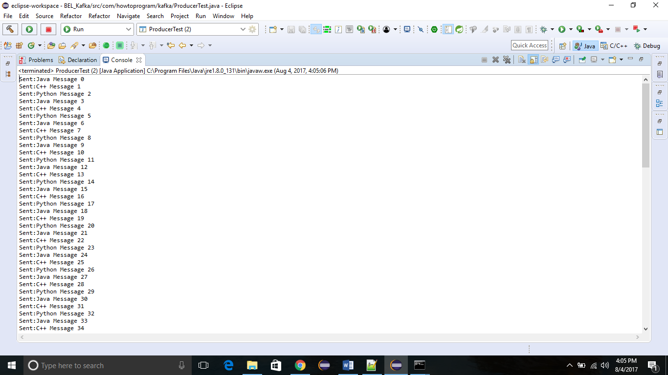

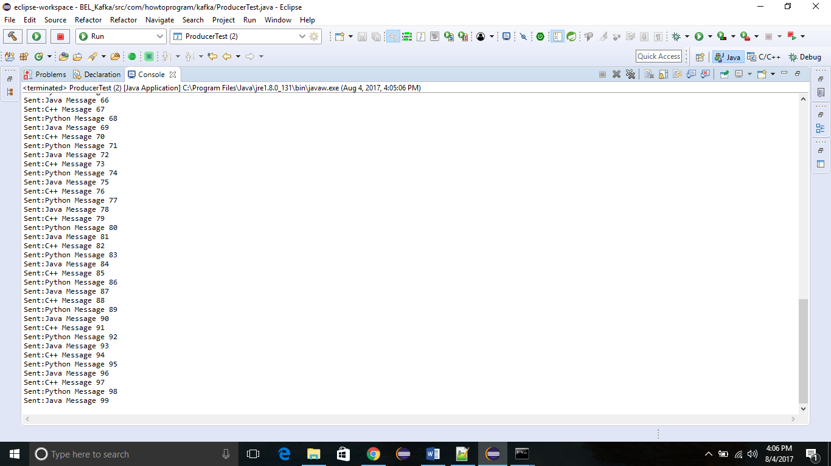

**Consumer_1 output**

This consumer is for retrieving the Java Information

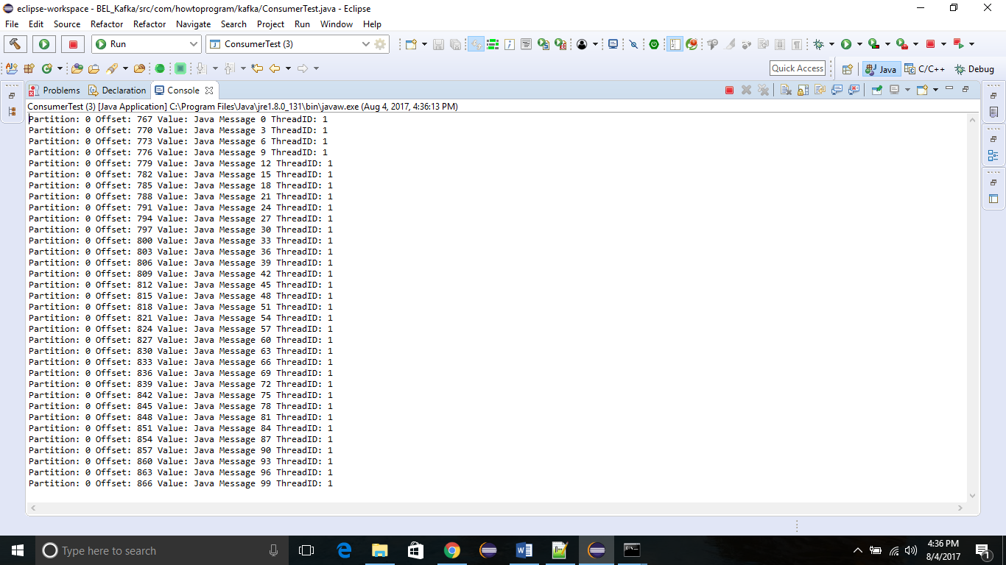

**Consumer_2 output**

This consumer is for retrieving the Python Information

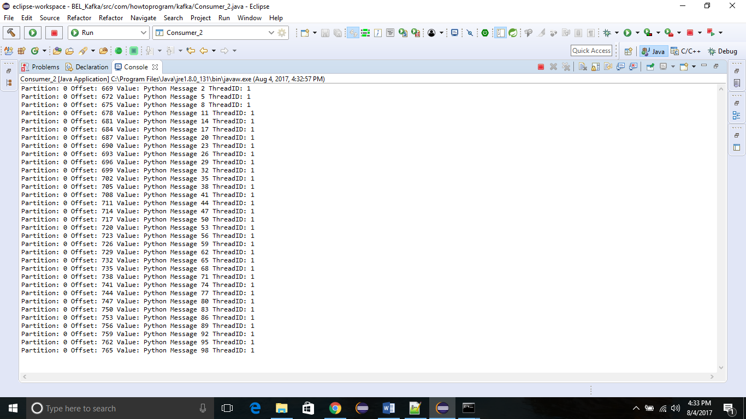

**Consumer_3 output**

This consumer is for retrieving the C++ information

